


- The students must first be divided in groups of 2 to 4 people, create a company and associated logo pertaining to their project at hand.
- Each group will have one Project Manager.
- Each phase (A, B and C) will have a different Project Manager.
- The Project Manager will submit the group report containing the items in the following sections. However, this is a team effort, and all group members are expected to contribute. If one or more members do not contribute, then they
will receive no marks for the group submission.
- Each Project Manager will submit a Project Manager report at the same time as the group project. A template is provided.
- Each Team Member who is not a project manager for the current phase will
submit a Team Member report at the same time as the group project. A template is provided.
- All report submissions will be digital through FanshaweOnline (FOL)

(5 Marks)
The report should have a cover sheet and follow the provided template.
- All items should be easy to read and understand.
- Any diagram should be large enough to read any text in the diagram. Large diagrams may be broken into parts as long as it is easy to follow.

5 marks
5 marks
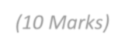
(10 Marks)
  General: | All areas must be completed with sufficient detail for the project selected and follow the format from the lectures
 | Document must contain the team’s name and logo
Scope Description: | Define what the scope of the project is by clearly  explaining all components required to successfully achieve the project description
Acceptance Criteria: | Must establish what the criteria is that will determine if  the project has been successfully completed
Validation / Testing Plan  / Exclusions: | Must clearly explain how the project will be tested and  what the requirements are for passing the tests. Clear, measurable outcomes must be determined, and testing methodologies outlined
Deliverables: | Must clearly define any item associated with the project that is a deliverable and must clearly any defined associated items that are not considered a deliverable
Project Coordination: | Must clearly explain how the project will be run. When  and where meetings are to happen, who is responsible for document creation and retention, how information  will be shared or where it will be stored. How will the input of each member be measured and tracked?

5 marks
5 marks
 | (10 Marks)
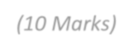  General: | All areas must be completed with sufficient detail for the project selected and follow the requirements as outlined in Lecture class
 | Documents must contain the team’s name and logo
Project Description: | Must accurately describe the project as outlined and  provide an understanding why this project is important to their company and what they expect the successful completion of the project will mean to their company
Constraints: | Must make an adequate attempt to determine the  constraints the project will face. Must include the basics; time, money, and manpower. Should show some attempt to understand other constraints that would affect the project if it were real
Risks: | Must show an understanding of the “high-level” risks  that could negatively impact the project’s success
Project Deliverables: | Must clearly define all the deliverables that would be  included in the selected project. Also consider items such as instruction manuals, software, hardware, where applicable
Project Milestones: | Milestones must be actual dates and must fall within the  assigned timeframe
Project Budget: | It is a guess at this point, but with your pre-graduate  background, as well as your involvement in minor projects, you should be able to come up with a dollar figure that might be wrong but realistic. The dollar amount should use Canadian formatting: a dollar sign first and thousands/millions separated by a comma. E.g.  $865,000 or $1,112,700


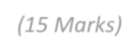
(15 Marks)

Format: Use the format given in class. For this project use three levels. The top level may be the Phase of the project. The bottom level should be your work packages
5 marks
Numbering: Use proper numbering for WBS task items

Completeness: Should obey the 100% Rule. Work packages should be
the correct size and mutually exclusive
5 marks
Work Packages: Should include at least 20 work packages, unless
approved by your instructor

Dictionary: Include a WBS Dictionary entry for one work package assigned to each member of your team (E.g. if you have five team members, include five dictionary items, each one assigned to a single team member.)
5 marks

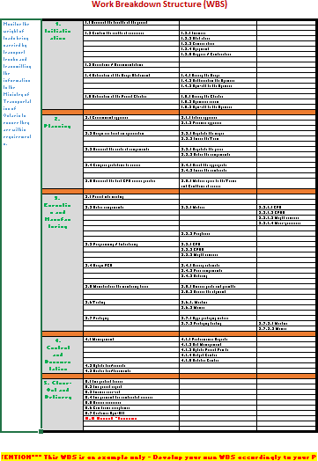
WBS Example:

